**Web Technologies**

**Assignment-2**

Name: V. Sreya

Roll Number: 1602-18-737-092

Helping Hands

Helping hands is a website that shows the user the location of nearby PHCs, blood banks and plasma centres. The website also gives you access to view the profiles of our reference doctors who happen to the best of covid case handlers. The user/patient can book an online appointment with any of the three reference doctors by filling up a form that is provided. Once the form is submitted, for patient’s reference, an acknowledgement mail is sent to the mail ID that he/she mentions in the form. For the hospital’s reference, the details of every patient who fills the form is stored into database.

**Program:**

index.html:

<!DOCTYPE html>

<html lang="en">

<head>

<title>Helping Hands</title>

<meta charset="utf-8">

<meta name="viewport" content="width=device-width, initial_scale=1">

<script src="https://kit.fontawesome.com/d7ae416123.js" crossorigin="anonymous"></script>

<link rel="stylesheet" href="style.css">

<link rel="stylesheet" href="https://cdn.jsdelivr.net/npm/bootstrap@5.0.1/dist/css/bootstrap.min.css">

<script src="https://ajax.googleapis.com/ajax/libs/jquery/3.5.1/jquery.min.js"></script>

<script src="https://cdn.jsdelivr.net/npm/@popperjs/core@2.9.2/dist/umd/popper.min.js"></script>

<script src="https://cdn.jsdelivr.net/npm/bootstrap@5.0.1/dist/js/bootstrap.min.js"></script>

</head>

`

<body>

<!--Navigation bar-->

<nav class="navbar navbar-expand-md navbar-light">

<div class="container-fluid">

<a class="navbar-brand" href="#"><img src="logo.jpeg" width=150 height=150></a>

<button class="navbar-toggler" type="button" data-toggle="collapse" data-target="#navbarResponsive">

<span class="navbar-toggler-icon"></span>

</button>

<div class="collapse navbar-collapse" id="navbarResponsive">

<ul class="navbar-nav">

<li class="nav-item active">

<a class="nav-link" href="#home">HOME</a>

</li>

<li class="nav-item">

<a class="nav-link" href="#phc">PHCs</a>

</li>

<li class="nav-item">

<a class="nav-link" href="#plasma">PLASMA CENTERS</a>

</li>

<li class="nav-item">

<a class="nav-link" href="#suggestion">SUGGESTIONS</a>

</li>

<li class="nav-item">

<a class="nav-link" href="#blood">BLOOD BANKS</a>

</li>

<li class="nav-item">

<a class="nav-link" href="#connect">CONNECT</a>

</li>

</ul>

</div>

</div>

</nav>

<!--Slide show-->

<div id="carouselExampleIndicators" class="carousel slide" data-bs-ride="carousel">

<div class="carousel-indicators">

<button type="button" data-bs-target="#carouselExampleIndicators" data-bs-slide-to="0" class="active" aria-current="true" aria-label="Slide 1"></button>

<button type="button" data-bs-target="#carouselExampleIndicators" data-bs-slide-to="1" aria-label="Slide 2"></button>

<button type="button" data-bs-target="#carouselExampleIndicators" data-bs-slide-to="2" aria-label="Slide 3"></button>

</div>

<div class="carousel-inner">

<div class="carousel-item active">

<img src="1.jpeg" class="d-block w-100" alt="1" height=500>

</div>

<div class="carousel-item">

<img src="hospi.jpeg" class="d-block w-100" alt="2" height=500>

</div>

<div class="carousel-item">

<img src="3.jpeg" class="d-block w-100" alt="3" height=500>

</div>

</div>

<button class="carousel-control-prev" type="button" data-bs-target="#carouselExampleIndicators" data-bs-slide="prev">

<span class="carousel-control-prev-icon" aria-hidden="true"></span>

<span class="visually-hidden">Previous</span>

</button>

<button class="carousel-control-next" type="button" data-bs-target="#carouselExampleIndicators" data-bs-slide="next">

<span class="carousel-control-next-icon" aria-hidden="true"></span>

<span class="visually-hidden">Next</span>

</button>

</div>

<br>

<br>

<br>

<!--Jumbotron-->

<section id="home">

<div class="jumbotron jumbotron-fluid">

<div class="container">

<h2 class="display-2"><b><i>HELPING HANDS</i></b></h2>

<hr class="first">

<p class="lead">Helping hands is your one stop solution to find the closest PHC, information about the doctors who are best in their fields and also details regarding blood banks, plasma etc.</p>

</div>

</div>

<br>

<br>

<!--Three missions-->

<div class="container-fluid padding">

<div class="row text-center padding">

<div class="col-xs-12 col-sm-6 col-md-4">

<i class="fas fa-hospital" style="font-size:200px;"></i>

<h3>PHCs</h3>

<p>Location of the nearest PHC.</p>

</div>

<div class="col-xs-12 col-sm-6 col-md-4">

<i class="fas fa-tint" style="font-size:200px;"></i>

<h3>BLOOD BANK</h3>

<p>Locations of the available blood banks.</p>

</div>

<div class="col-sm-12 col-md-4">

<i class="fas fa-user-md" style="font-size:200px;"></i>

<h3>DOCTORS</h3>

<p>Best covid doctors.</p>

</div>

</div>

</div>

<br>

<br>

<br>

</section>

<div class="back">

<hr class="light">

<section id="phc">

<!--PHC locations-->

<br>

<br>

<br>

<div class="container-fluid padding">

<div class="row text-center padding">

<div class="col-12">

<h1 class="display-2">PHC Locations</h1>

<hr class="small">

<br>

</div>

<center><img src="hosp.jpg"></center>

<div class="container">

<br><br>

<div class="row row-cols-2 row-cols-lg-5 g-2 g-lg-3">

<div class="col">

<div class="p-3 border bg-dark">

<p class="text-light" align="center">

<a href="https://www.google.com/maps/dir/17.4356884,78.4183459/sri+ram+nagar+hospital+(+PHC+),+8-3-168%2FE%2F2%2F50R51,+Rajeev+Nagar,+Hyderabad,+Telangana+500045/@17.4396331,78.4139345,15z/data=!3m1!4b1!4m9!4m8!1m1!4e1!1m5!1m1!1s0x3bcb9118b272e2c1:0xb2fbc65d52d99531!2m2!1d78.4240495!2d17.4485092"><b>AMEERPET</b></a>

</p>

</div>

</div>

<div class="col">

<div class="p-3 border bg-dark">

<p class="text-light" align="center">

<a href="https://www.google.com/maps/dir/17.4356884,78.4183459/Government+Hospital+and+Urban+Primary+Health+Care,+Bus+stop+opposite+lane,+Venkat+Reddy+Nagar,+Amberpet,+Hyderabad,+Telangana+500013/@17.4155671,78.4181322,12z/data=!3m1!4b1!4m9!4m8!1m1!4e1!1m5!1m1!1s0x3bcb99024f9a7e0f:0x43afc748a334352a!2m2!1d78.5281943!2d17.3861221"><b>AMBERPET</b></a>

</p>

</div>

</div>

<div class="col">

<div class="p-3 border bg-dark">

<p class="text-light" align="center">

<a href="https://www.google.com/maps/dir//Government+Urban+Primary+Health+Centre,+Gachibowli+-+Miyapur+Rd,+Vinayaka+Nagar,+Hafeezpet,+Telangana+500049/data=!4m6!4m5!1m1!4e2!1m2!1m1!1s0x3bcb924171c1a627:0x6a1de11b25122851?sa=X&ved=0ahUKEwjmr46awIfwAhVk4jgGHXNOC0cQ48ADCEMwAA"><b>GACHIBOWLI</b></a>

</p>

</div>

</div>

<div class="col">

<div class="p-3 border bg-dark">

<p class="text-light" align="center">

<a href="https://www.google.com/maps/dir/17.4356884,78.4183459/URBAN+PRIMARY+HEALTH+CENTRE,+12-18-22,+Moosapet+Cross+Rd,+Janta+Nagar,+Patel+Nagar,+Moosapet,+Hyderabad,+Telangana+500018/@17.4500923,78.4072339,14z/data=!3m1!4b1!4m9!4m8!1m1!4e1!1m5!1m1!1s0x3bcb915f0b305cf7:0x1a41ed4cfcfb85a5!2m2!1d78.4197773!2d17.469201"><b>KUKATPALLY</b></a>

</p>

</div>

</div>

<div class="col">

<div class="p-3 border bg-dark">

<p class="text-light" align="center">

<a href="https://www.google.com/maps/dir/17.4356884,78.4183459/Urban+Primary+Health+Care+Centre,+10-2-318%2F1%2FA%2F11,+Feroz+Gandhi+Nagar,+Indira+Nagar,+Asif+Nagar+North,+Hyderabad,+Telangana+500264/@17.4123366,78.3951425,13z/data=!3m1!4b1!4m9!4m8!1m1!4e1!1m5!1m1!1s0x3bcb970d59c91c7f:0x361c85a8b7fce229!2m2!1d78.4519989!2d17.3907469"><b>BANJARA HILLS</b></a>

</p>

</div>

</div>

<div class="col">

<div class="p-3 border bg-dark">

<p class="text-light" align="center">

<a href="https://www.google.com/maps/dir//Government+Urban+Primary+Health+Center,+NRR+Puram,+Borabanda,+Hyderabad,+Telangana+500018/data=!4m6!4m5!1m1!4e2!1m2!1m1!1s0x3bcb91135f5556bd:0x9268579c0a70c5ca?sa=X&ved=0ahUKEwjZtInzvofwAhVKzjgGHS0fB4IQ48ADCEkwAQ"><b>JUBILEE HILLS</b></a>

</p>

</div>

</div>

<div class="col">

<div class="p-3 border bg-dark">

<p class="text-light" align="center">

<a href="https://www.google.com/maps/dir/17.4356884,78.4183459/Govt.PHC.HOSPITAL,D.DHARMARAM,+Mission+Hospital+Internal+Rd,+Shantinagar+Colony,+Mustafa+Nagar,+Khammam,+Telangana+507001/@17.4370259,78.4152632,14z/data=!3m1!4b1!4m9!4m8!1m1!4e1!1m5!1m1!1s0x3bcb90c422581db3:0xb7d65eda5b0d5008!2m2!1d78.4462452!2d17.4415528"><b>PANJAGUTTA</b></a>

</p>

</div>

</div>

<div class="col">

<div class="p-3 border bg-dark">

<p class="text-light" align="center">

<a href="https://www.google.com/maps/dir/17.4356884,78.4183459/Nampally+Government+Hospital,+Government+Hp,+Bazar+Ghat,+Nampally,+Hyderabad,+Telangana+500001/@17.4142057,78.4085372,13z/data=!3m1!4b1!4m9!4m8!1m1!4e1!1m5!1m1!1s0x3bcb976e70000001:0xf396212512e5289c!2m2!1d78.4632945!2d17.3922731"><b>NAMPALLY</b></a>

</p>

</div>

</div>

<div class="col">

<div class="p-3 border bg-dark">

<p class="text-light" align="center">

<a href="https://www.google.com/maps/dir//Primary+Health+Centre+Serilingampally,+Gulmohar+Park+Cross+Road,+opposite+Andhra+Bank,+Adarsh+Nagar,+Serilingampalle+(M),+Telangana+500019/data=!4m6!4m5!1m1!4e2!1m2!1m1!1s0x3bcb92e926651669:0xf3fe811ab559b051?sa=X&ved=0ahUKEwi4w4uwwIfwAhXD4jgGHezjChAQ48ADCFEwAQ"><b>SERLINGAMPALLY</b></a>

</p>

</div>

</div>

<div class="col">

<div class="p-3 border bg-dark">

<p class="text-light" align="center">

<a href="https://www.google.com/maps/dir//UPHC+Patancheru,+JP+Colony,+Patancheruvu,+Telangana+502319/data=!4m6!4m5!1m1!4e2!1m2!1m1!1s0x3bcbf2bfe296e329:0xad459788c5793c8d?sa=X&ved=0ahUKEwiwo925wIfwAhXe4zgGHXT_BfQQ48ADCHEwBQ"><b>PATANCHERU</b></a>

</p>

</div>

</div>

</div>

</div>

</div>

</div>

<br>

<br>

<br>

<hr class="light">

</section>

</div>

<br>

<br>

<br>

<!--plasma centers-->

<section id="plasma">

<div class="container-fluid padding">

<div class="row text-center padding">

<div class="col-12">

<h1 class="display-2">Plasma Centres</h1>

<hr class="small">

</div>

<br>

<br>

<br>

<marquee>

<h4><b>Click on the emoticon to get the location!</b></h4>

</marquee>

<br>

<br>

<br>

<center><img src="plasma.jpg" width=500 height=350><br><br><br></center>

<div class="col-sm-3">

<a href="https://www.google.co.in/search?q=plasma%20centres%20in%20hyderabad&ie=UTF-8&oe=UTF-8&hl=en-in&client=safari&tbs=lf:1,lf_ui:2&tbm=lcl&rflfq=1&num=10&rldimm=11659226495270990642&lqi=ChtwbGFzbWEgY2VudHJlcyBpbiBoeWRlcmFiYWRI08KJveWAgIAIWjUKDnBsYXNtYSBjZW50cmVzEAAQARgBGAMiG3BsYXNtYSBjZW50cmVzIGluIGh5ZGVyYWJhZJIBFWJsb29kX2RvbmF0aW9uX2NlbnRlcqoBFhABKhIiDnBsYXNtYSBjZW50cmVzKAA&ved=2ahUKEwik4PjtrfTwAhVRzjgGHVfGDVwQvS4wAHoECAQQKw&rlst=f#rlfi=hd:;si:11659226495270990642,l,ChtwbGFzbWEgY2VudHJlcyBpbiBoeWRlcmFiYWRI08KJveWAgIAIWjUKDnBsYXNtYSBjZW50cmVzEAAQARgBGAMiG3BsYXNtYSBjZW50cmVzIGluIGh5ZGVyYWJhZJIBFWJsb29kX2RvbmF0aW9uX2NlbnRlcqoBFhABKhIiDnBsYXNtYSBjZW50cmVzKAA;mv:[[17.5333263,78.5639834],[17.321144,78.3295432]];tbs:lrf:!1m4!1u3!2m2!3m1!1e1!1m4!1u2!2m2!2m1!1e1!2m1!1e2!2m1!1e3!3sIAE,lf:1,lf_ui:2https://www.google.co.in/maps/dir/17.4356988,78.4183354/Hyderabad+Blood+Donors,+9-1-127%2F1%2FD%2F1,+Madhava+Nursing+Home+S+D+Road,+Lane+Opp+St+Marys+Church,+Secunderabad,+Telangana+500003/@17.4247743,78.4116219,13z/data=!3m1!4b1!4m9!4m8!1m1!4e1!1m5!1m1!1s0x3bcb9b07c2a6f8eb:0xa1cde4b966733332!2m2!1d78.476589!2d17.4059551?hl=en-in" id="plasma"><img src="p1.jpeg" alt="plasma" width=150 height=150></a>

</div>

<div class="col-sm-3">

<a href="https://www.google.co.in/maps/dir//Mother+Teresa+Blood+Centre%7C+Thalassemia+Blood+Donation+Centre,+4th+Floor,+Kosal+Sai+Plaza+Near+Sai+Ayush+Ayurveda,+Hyderabad+Laser+Surgery+Hospital+Madinaguda,+Miyapur,+Hyderabad,+Telangana+500049/data=!4m6!4m5!1m1!4e2!1m2!1m1!1s0x3bcb936f0adf5127:0x98d8ba930dae3b52?sa=X&hl=en-in&ved=2ahUKEwis8pbwrfTwAhXK4jgGHQtyAnEQ48ADMAJ6BAgBECw"><img src="p2.jpeg" alt="plasma" width=150 height=150></a>

</div>

<div class="col-sm-3">

<a href="https://www.google.co.in/maps/dir/17.4356988,78.4183354/Medipluses+Blood+Collection+Service,+G1,Hari+hara+house,+Bandari+Layout,+Vasanth+Nagar+Colony,+Nizampet,+Hyderabad,+Telangana+500090/@17.4751398,78.3389571,12z/data=!3m1!4b1!4m9!4m8!1m1!4e1!1m5!1m1!1s0x3bcb9103f88a7295:0x827f49837a17771f!2m2!1d78.3851682!2d17.5219505?hl=en-in" id="plasma"><img src="p3.jpeg" alt="plasma" width=150 height=150></a>

</div>

<div class="col-sm-3">

<a href="https://www.google.co.in/maps/dir/17.4356988,78.4183354/Chiranjeevi+Eye+and+Blood+Bank,+8-2-293%2F82%2FA%2FC,+Rd+Number+1,+Jubilee+Hills,+Hyderabad,+Telangana+500033/@17.4311069,78.4050669,15z/data=!3m1!4b1!4m9!4m8!1m1!4e1!1m5!1m1!1s0x3bcb97355392944b:0xcec0c4c1f146bf75!2m2!1d78.41654!2d17.428203?hl=en-in" id="plasma"><img src="p4.jpeg" alt="plasma" width=150 height=150></a>

</div>

</div>

</div>

<br>

<br>

<br>

</section>

<div class="back">

<hr class="light">

<!--Doctors suggested-->

<section id="suggestion">

<br>

<br>

<br>

<div class="container-fluid padding">

<div class="row welcome text-center">

<div class="col-12">

<h1 class="display-2">Meet the doctors!</h1>

<hr class="small">

<br>

<br>

</div>

</div>

</div>

<!--doctor profiles-->

<div class="container-fluid padding">

<div class="row padding">

<div class="col-md-4">

<div class="card">

<img class="card-imd-top" src="amar.jpg" width=500 height=400>

<div class="card-body">

<h4 class="card-title">Dr. Amar Singh</h4>

<button onclick="myFunction1()">See Profile</button>

<script>

function myFunction1() {

alert("Name of the doctor: Amar Singh\r\nSpecialisation: MBBS,General physician\r\nExperience: 9 years \r\nContact number: +91-9875543775");

}

</script>

</div>

</div>

</div>

<div class="col-md-4">

<div class="card">

<img class="card-imd-top" src="sarika.jpg" width=500 height=400>

<div class="card-body">

<h4 class="card-title">Dr. Sarika Kumar</h4>

<button onclick="myFunction2()">See Profile</button>

<script>

function myFunction2() {

alert("Name of the doctor: Sarika Kumar\r\nSpecialisation: MBBS, Surgeon\r\nExperience: 11 years \r\nContact number: +91-9947833644");

}

</script>

</div>

</div>

</div>

<div class="col-md-4">

<div class="card">

<img class="card-imd-top" src="keshav.jpg" width=500 height=400>

<div class="card-body">

<h4 class="card-title">Dr. Keshav Iyer</h4>

<button onclick="myFunction3()">See Profile</button>

<script>

function myFunction3() {

alert("Name of the doctor: Keshav Iyer\r\nSpecialisation: MD, Cardiac specialist\r\nExperience: 15 years \r\nContact number: +91-8857943778");

}

</script>

</div>

</div>

</div>

<center>

<div class="col-12">

<br><br>

<button onclick="location.href='test.php'">Book online appointment</button>

</div>

</center>

</div>

</div>

<br>

<br>

<br>

</section>

<hr class="light">

</div>

<!--blood banks-->

<section id="blood">

<br>

<br>

<div class="container-fluid padding">

<div class="row text-center">

<div class="col-12">

<h1 class="display-2">The Blood Banks</h1>

<hr class="small">

</div>

<br>

<marquee>

<h4><b>Click on the gif to get the location!</b></h4>

</marquee>

<br>

<br>

<div class="col-sm-12 col-md-6">

<a href="https://www.google.com/maps/dir//Chiranjeevi+Eye+and+Blood+Bank,+8-2-293%2F82%2FA%2FC,+Rd+Number+1,+Jubilee+Hills,+Hyderabad,+Telangana+500033/data=!4m6!4m5!1m1!4e2!1m2!1m1!1s0x3bcb97355392944b:0xcec0c4c1f146bf75?sa=X&hl=en-GB&ved=2ahUKEwj7pZDO8_XwAhVSWysKHQSMBjgQ48ADMAB6BAgBEBM" id="giffy1"><img src="gif1.gif" alt="giffy1" width=200 height=200></a>

<br><br>

</div>

<div class="col-sm-12 col-md-6">

<a href="https://www.google.com/maps/dir/17.4356884,78.4183459/No+1,+Red+Cross+Blood+Bank,+9-310,+Rd+Number+6,+Banjara+Hills,+Hyderabad,+Telangana+500044/@17.4257379,78.4125615,14z/data=!3m1!4b1!4m9!4m8!1m1!4e1!1m5!1m1!1s0x3bcb9732458c34a3:0xe0f6973316d3f883!2m2!1d78.4424697!2d17.4221229?hl=en-GB" id="giffy2"><img src="gif4.gif" alt="giffy2" width=200 height=200></a>

<br><br>

</div>

<br>

<div class="col-sm-12 col-md-6">

<a href="https://www.google.com/maps/dir/17.4356884,78.4183459/Vivekananda+Blood+Bank,+H.No+12-2-790%2F3%2FB,+2nd+floor+Ayodhya+Nagar,+Opp+Lane+to+Piller,+No+28,+PV+Narasimha+Rao+Expy,+Ayodhya+Nagar+Colony,+Mehdipatnam,+Hyderabad,+Telangana+500028/@17.4194985,78.417109,14z/data=!3m1!4b1!4m9!4m8!1m1!4e1!1m5!1m1!1s0x3bcb971cb8baffbd:0xebe315cda26a294a!2m2!1d78.43521!2d17.394536?hl=en-GB" id="giffy3"><img src="gif3.gif" alt="giffy3" width=200 height=200></a>

</div>

<div class="col-sm-12 col-md-6">

<a href="https://www.google.com/maps/dir/17.4356884,78.4183459/Gene+Blood+Bank,+Kanthisikara+Complex,+Beside+FMS+Dental+Clinic,+Opposite+Model+House,+Panjagutta,+Hyderabad,+Telangana+500082/@17.4337958,78.4178976,14z/data=!3m1!4b1!4m9!4m8!1m1!4e1!1m5!1m1!1s0x3bcb974add16b2c3:0xc890f2a7138bd3a0!2m2!1d78.4546509!2d17.4248622?hl=en-GB" id="giffy4"><img src="gif2.gif" alt="giffy4" width=200 height=200></a>

</div>

</div>

</div>

<br>

<br>

</section>

<hr class="light">

<section id="connect">

<br>

<br>

<br>

<br>

<!--connect-->

<div class="container-fluid padding">

<div class="row text-center padding">

<div class="col-12">

<h2><b>Connect</b></h2>

</div>

<div class="col-12 social padding">

<br>

<a href="#"><i class="fab fa-facebook" style="font-size:50px;"></i></a>

<a href="#"><i class="fab fa-twitter" style="font-size:50px;"></i></a>

<a href="#"><i class="fab fa-google-plus-g" style="font-size:50px;"></i></a>

<a href="#"><i class="fab fa-instagram" style="font-size:50px;"></i></a>

<a href="#"><i class="fab fa-youtube" style="font-size:50px;"></i></a>

</div>

</div>

</div>

<br>

<br>

<br>

<br>

<br>

</section>

<!--footer-->

<footer>

<div class="container-fluid padding">

<div class="row text-center">

<div class="col-md-4">

<hr class="light">

<h3><b>Contact</b></h3>

<hr class="light">

<p><span class="fas fa-phone" style="font-size:40px;"></span> 040-23456789</p>

<p><span class="far fa-envelope" style="font-size:40px;"></span> helpinghands@gmail.com</p>

</div>

<div class="col-md-4">

<img src="logo.jpeg" width=300 height=300>

</div>

<div class="col-md-4">

<hr class="light">

<p><b>

<h3>Important Links</h3>

</b></p>

<hr class="light">

<p><a href="http://www.tsmsidc.telangana.gov.in/assets_medak.php">Telangana PHC website</a></p>

<p><a href="https://covid19.telangana.gov.in/">Telangana COVID-19 track</a></p>

<p><a href="https://covid19.telangana.gov.in/health-facilities/testing-centres/">COVID test centers</a></p>

<p><a href="https://www.justdial.com/Hyderabad/Blood-Banks/nct-10049054">Blood banks in Hyderabad</a></p>

<b>

<p>Helpline number: 108</p>

</b>

</div>

<div class="col-md-12">

<br>

<hr class="light">

<h5>&copy;helpinghands.com</h5>

</div>

</div>

</div>

</footer>

</body>

</html>

Style.css(For the website):

@import url('https://fonts.googleapis.com/css?family=Poppins:400,500,700');

html,

body {

height: 100%;

width: 100% font-family: 'Poppins', sans-serif;

color: #222;

}

.navbar {

background: #DACB9B

}

.navbar-nav li {

padding-right: 20px;

}

.nav-link {

font-size: 1.1em !important;

}

.jumbotron {

padding: 1rem;

border-radius: 0;

}

.padding {

padding-bottom: 2rem

}

.fa-hospital {

color: #4169E1;

}

.fa-tint {

color: red;

}

.fa-user-md {

color: forestgreen;

}

.fa-hospital,

.fa-tint,

.fa-user-md {

margin: 2rem;

}

.social a {

padding: 3rem;

}

.fa-facebook {

color: #3b5998

}

.fa-twitter {

color: #00aced;

}

.fa-google-plus-g {

color: #dd4b39

}

.fa-instagram {

color: #517fa8

}

.fa-youtube {

color: #bb0000;

}

.fa-facebook:hover,

.fa-twitter:hover,

.fa-google-plus-g:hover,

.fa-instagram:hover,

.fa-youtube:hover {

color: #d5d5d5;

}

footer {

background-color: #3f3f3f;

color: #d5d5d5;

padding-top: 2rem;

}

hr.light {

border-top: 2px solid #d5d5d5;

margin-top: .8rem;

margin-bottom: 1rem;

}

footer a {

color: #d5d5d5;

}

.back {

background: #FEECC7;

}

hr.first{

border-top: 5px solid #000000;

width: 50%;

margin-top: .8rem;

margin-bottom: 1rem;

}

hr.small {

border-top: 4px solid #000000;

width: 50%;

margin-left: 25%;

margin-top: .8rem;

margin-bottom: 1rem;

}

Form.html:

<html>

<head>

<title>Appointments</title>

<link rel="stylesheet" href="style1.css">

</head>

<body>

<div class="app-title">

<h1>Helping Hands Appointments</h1>

</div>

<div class="appointment-form">

<form method="post" action=”acknowledgement.php”>

<div class="col-12">

<input name="name" type="text" class="form-control" placeholder="Name" required>

</div>

<div class="col-12">

<input name="email" type="email" class="form-control" placeholder="Email ID" required>

</div>

<div class="col-12">

<input name="phone" type="tel" class="form-control" placeholder="Phone Number" pattern='[0-9]{10}' required>

</div>

<div class="col-12">

<select name="doctor" class="form-select" placeholder="Choose a doctor">

<option selected>Choose a Doctor</option>

<option>Dr.Amar Singh</option>

<option>Dr. Sarika Kumar</option>

<option>Dr. Keshav Iyer</option>

</select>

</div>

<div class="col-12">

<select name="slot" class="form-select" placeholder="Choose a slot">

<option selected>Choose a slot</option>

<option>10:00 A.M</option>

<option>12:00 P.M</option>

<option>2:00 P.M</option>

<option>4:00 P.M</option>

<option>6:00 P.M</option>

<option>8:00 P.M</option>

</select>

</div>

<div class="col-12">

<button type="submit" name="bookAppointment" class="btn submit">Book Appointment</button>

</div>

</form>

</div>

</body>

</html>

Style1.css(For the form):

body{

margin: 0;

padding: 0;

text-align: center;

background: linear-gradient(rgba(0,0,50,0.5),rgba(0,0,50,0.5)),url(bg.jpeg);

background-size: cover;

background-position: center;

font-family: sans-serif;

}

.app-title

{

margin-top: 100px;

color: white;

text-transform: uppercase;

transition: all 4s ease-in-out;

}

.app-title h1{

font-size: 30px;

line-height: 10px;

}

form

{

margin-top: 50px;

transition: all 4s ease-in-out;

}

.form-control

{

width: 600px;

border: none;

outline: none;

border-bottom: 1px solid black;

font-size: 18px;

margin-bottom: 16px;

}

.form-select

{

width: 600px;

background: transparent;

border: none;

outline: none;

border-bottom: 1px solid black;

color: black;

font-size: 18px;

margin-bottom: 16px;

}

input

{

height: 40px;

}

form .submit

{

background: blue;

border-color:transparent;

color: white;

font-size: 20px;

font-weight: bold;

letter-spacing: 2px;

height: 50px;

margin-top: 20px;

}

form .submit:hover

{

background-color: lightblue;

}

Acknowledgement.php:

<?php

if(isset($_POST['bookAppointment']))

{

if(filter_var($_POST['email'],FILTER_VALIDATE_EMAIL))

{

$username = $_POST['name'];

$to = $_POST['email'];

$userphone = $_POST['phone'];

$doc = $_POST['doctor'];

$time = $_POST['slot'];

$subject = 'Appointment confirmation acknowledgment.';

$message = "Hey, ".$username."\r\nThis is to confirm your appointment booking with ".$doc.".\r\nYour registered number is ".$userphone.". You will get a call on this number at ".$time.".\r\nThank you for choosing us.\n\nRegards,\r\nHelping Hands.";

$headers = "From: helpinghandsofficialss@gmail.com\r\nReply-To: helpinghandsofficialss@gmail.com";

$status = mail($to, $subject, $message, $headers);

if($status==true)

{

echo '<script>alert("Appointment booked! Confirmation mail sent.")</script>';

}

else

{

echo '<script>alert("Appointment not booked! Please try again.")</script>';

}

}

$name = filter_input(INPUT_POST,'name');

$phone = filter_input(INPUT_POST,'phone');

$doctor = filter_input(INPUT_POST,'doctor');

$timeslot = filter_input(INPUT_POST,'slot');

if(!empty($name)){

if(!empty($phone)){

if(!empty($doctor)){

if(!empty($timeslot)){

$host = "localhost";

$dbusername = "root";

$dbpassword = "";

$dbname = "helpinghands";

// connection creation

$conn = new mysqli($host, $dbusername, $dbpassword, $dbname);

if(mysqli_connect_error()){

die('Connection Error('.mysqli_connect_error().')'.mysqli_connect_error());

}

else{

$sql = "INSERT INTO patient_details (Name, PhoneNumber,Doctor,Slot) values ('$name','$phone','$doctor','$timeslot')";

if($conn->query($sql)){

echo "new record inserted";

}

else{

echo "Error: ". $sql ."<br>". $conn->error;

}

$conn->close();

}

}

else{

echo "Please choose a time slot";

die();

}

}

else{

echo "Please choose a doctor.";

die();

}

}

else{

echo "Phone number should not be empty!";

die();

}

}

else{

echo "Name should not be empty!";

die();

}

}

?>

OUTPUT:

Home Page: With carousel

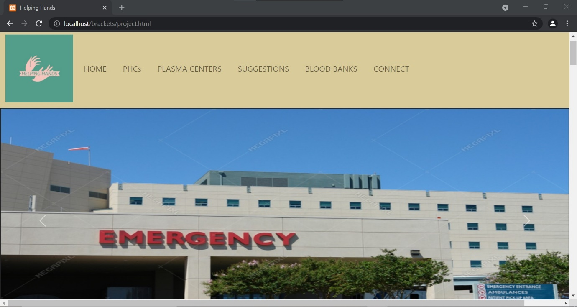



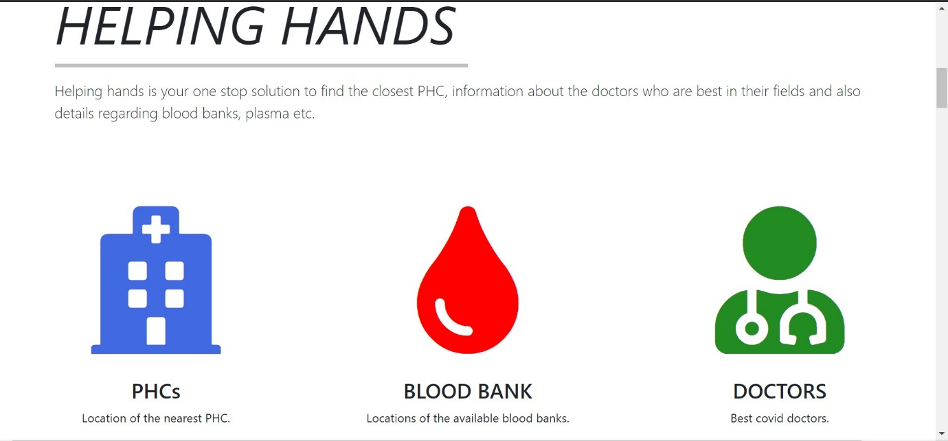

PHC locations:

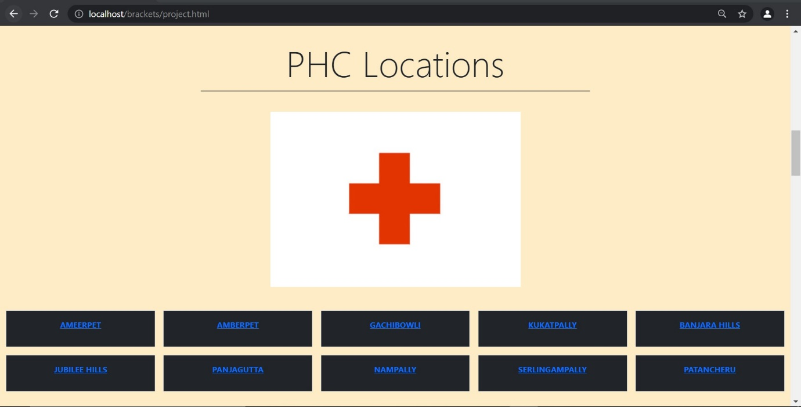

Plasma Centre locations:

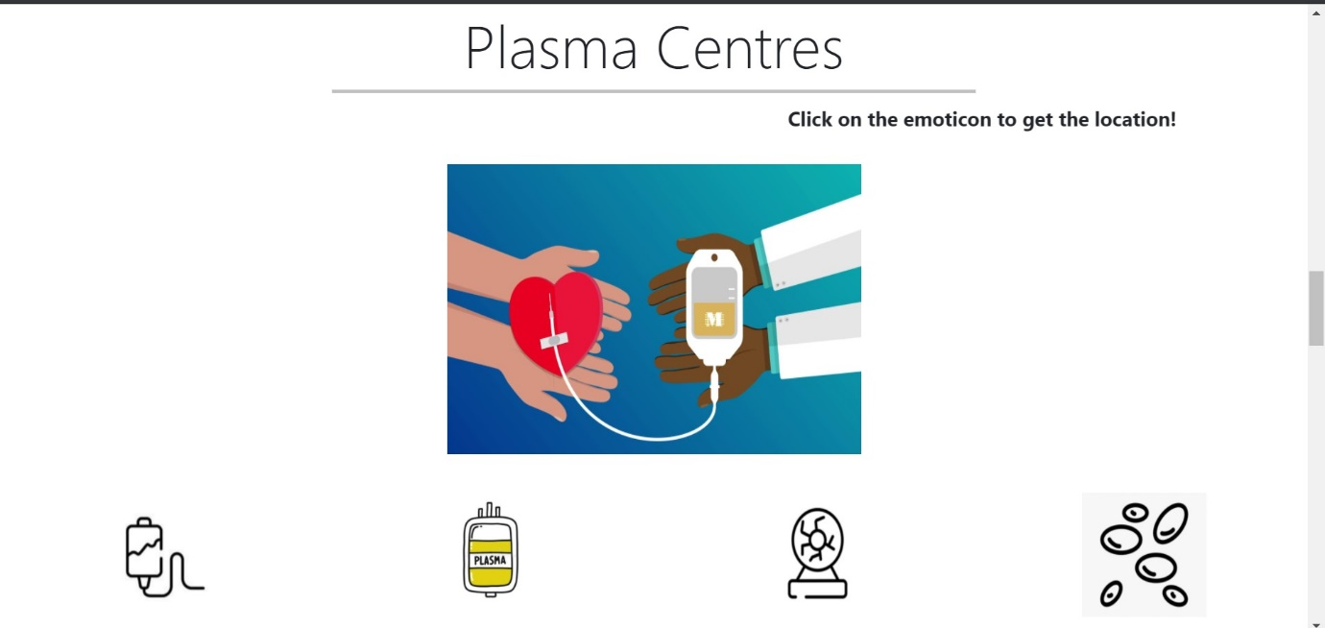

Reference Covid doctors:

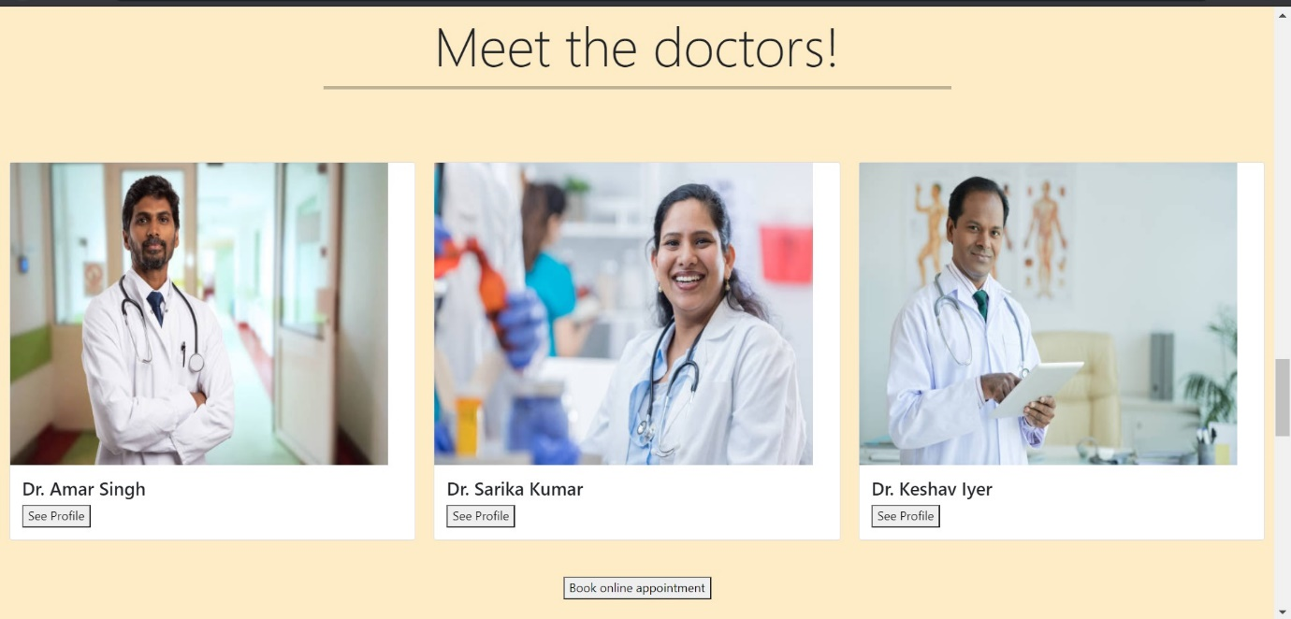

On clicking ‘See Profile’: 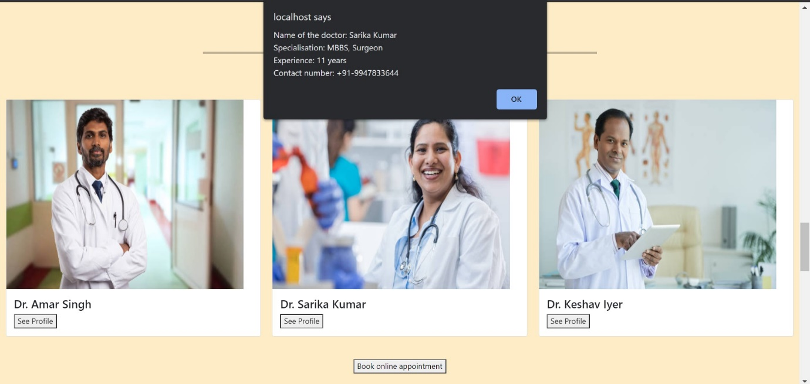

On clicking ‘Book online appointment’:

Form:

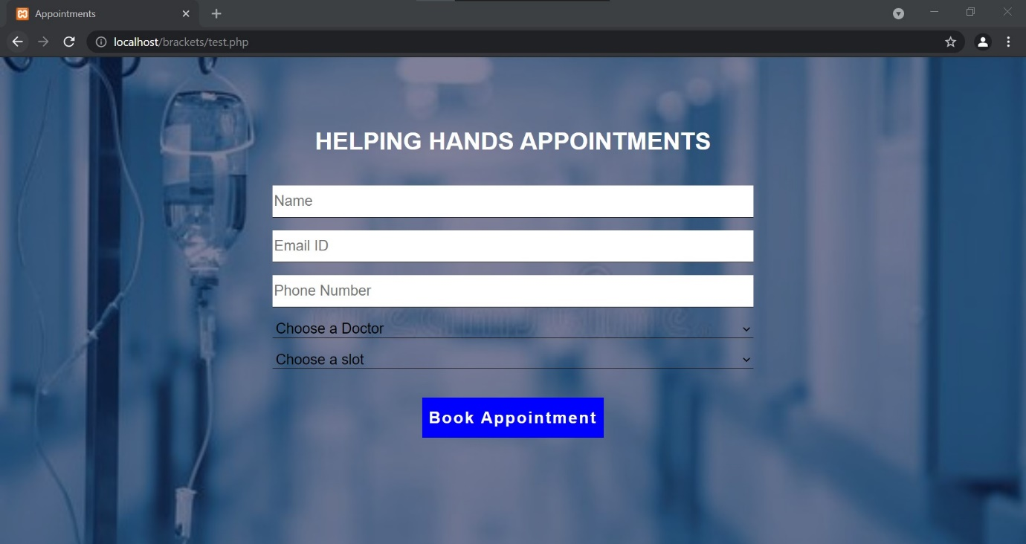

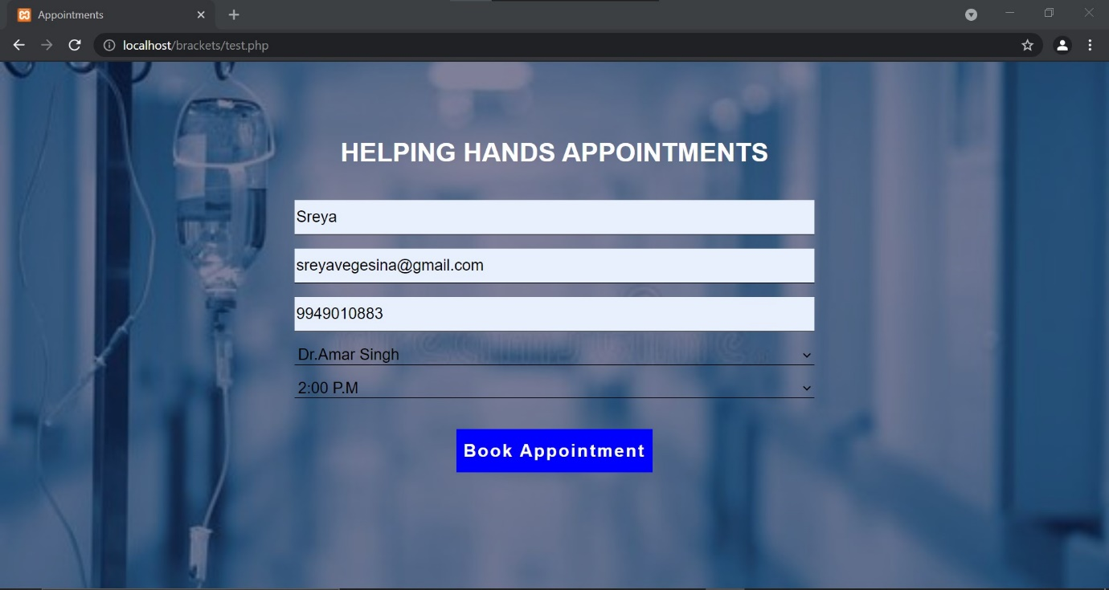

On clicking ‘Book Appointment’:

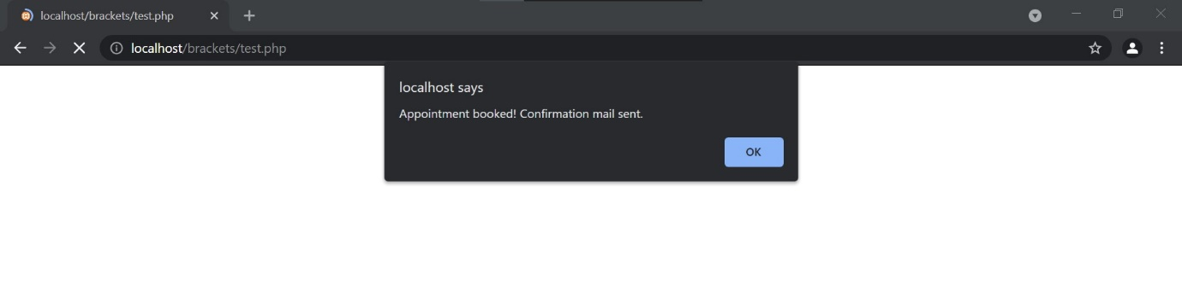

Blood banks locations:

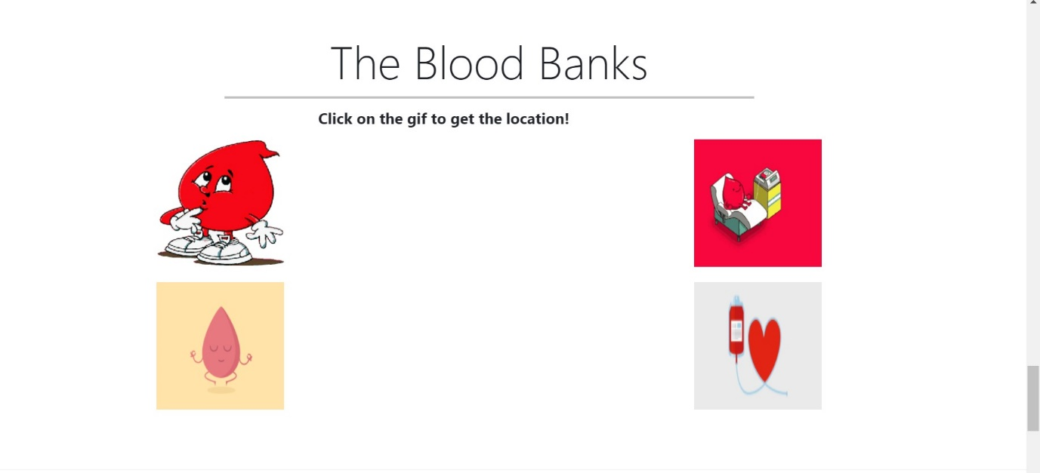

Footer: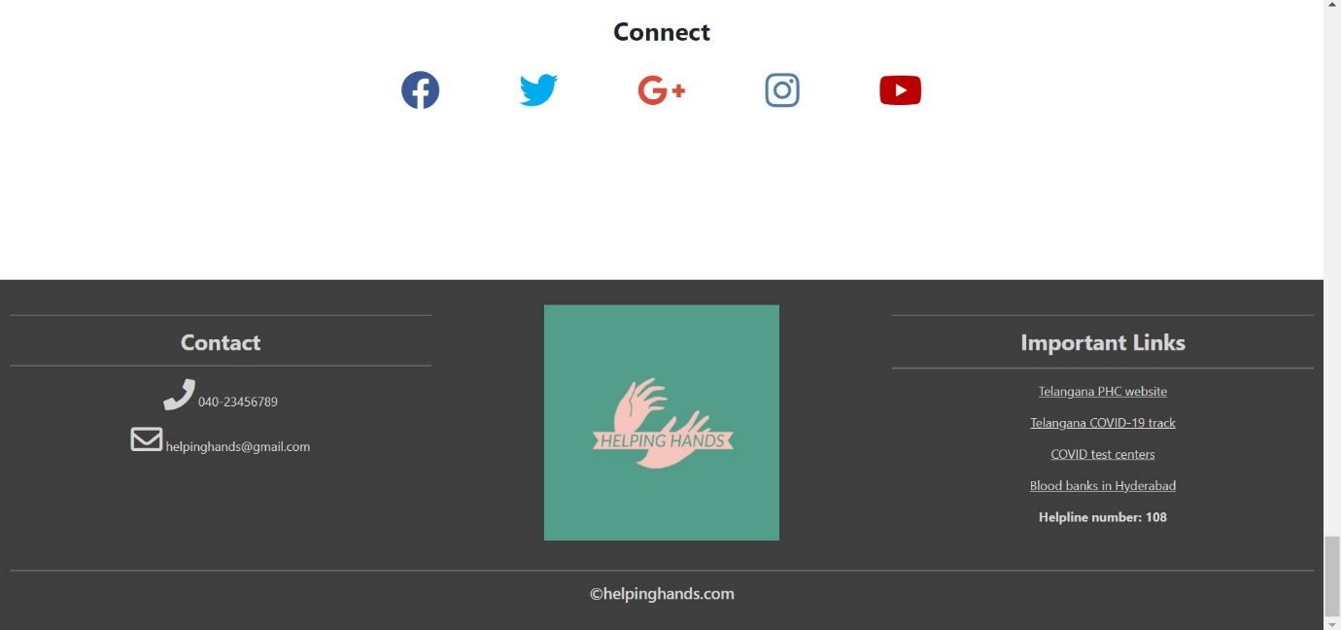

Acknowledgement mail:

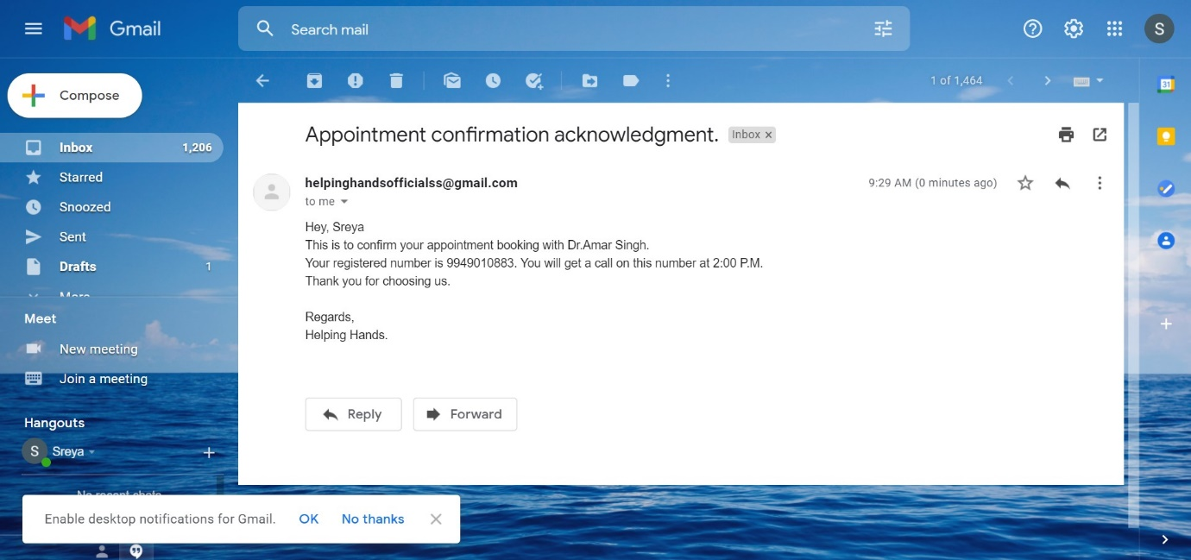

Data inserted into database:

